|  |  |  |
| --- | --- | --- |
| **LAB221 Assignment** | **Type:** | **Short Assignment** |
| **Code:** | **J2.S.P0126** |
| **LOC:** | **10** |
| **Slot(s):** | **1** |

**Title** Colors choose

**Background Context**

A radio button or option button is a graphical control element that allows the user to choose only one of a predefined set of options.

Radio buttons are arranged in groups of two or more and displayed on screen as, for example, a list of circular holes that can contain white space (for unselected) or a dot (for selected). Each radio button is normally accompanied by a label describing the choice that the radio button represents. The choices are mutually exclusive; when the user selects a radio button, any previously selected radio button in the same group becomes deselected (making it so only one can be selected). Selecting a radio button is done by clicking the mouse on the button, or the caption, or by using a keyboard shortcut.

**Program Specifications**

Design a program that allows users change color using radio button.

***Function details:***

Program has four radios button to choose color.

***Expectation of User interface:***

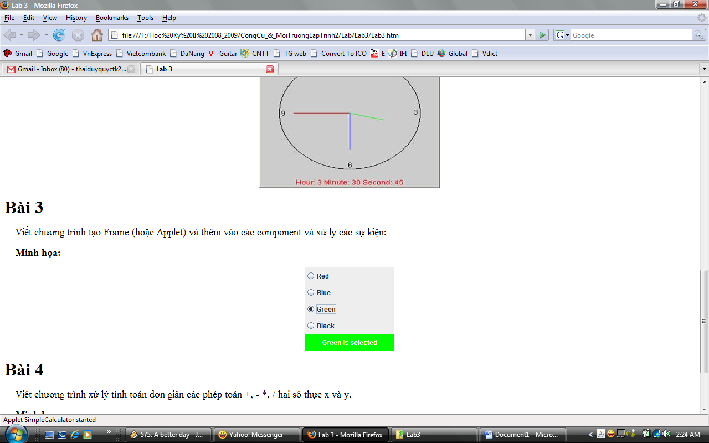

**Guidelines**